Shopping

Activity | Purpose | Page
1 | Food Introduction  - to review food vocabulary | 2
2 | Count/Non-Count Nouns  - to introduce count and non-count nouns  - to introduce quantities and containers | 5
3 | John Goes Shopping  - to review food vocabulary  - to introduce shopping and quantity vocabulary  - to introduce and practice cashier/ customer dialogue | 11
4 | What is It?  - to review clothing vocabulary | 14
5 | It Doesn’t Fit  - to practice using too and not enough  - to introduce a dialogue for returning and exchanging items in a store  - review clothing adjectives | 18
6 | Shopping Survey  - to ask questions for a class survey  - to review adverbs of frequency  - to discuss the answers on a survey  - to form survey questions | 21
7 | The Height, Depth and Width  - to learn measurements vocabulary  - to ask questions specific to buying large household items | 23

1. Food Introduction

Activity 1

Purpose:
- to review food vocabulary

CLB Level:
3 +

Time:
35 minutes

Materials:
- Side by Side worksheet or Food Vocabulary Pictures for each learner
- blank pieces of paper for each learner
- one set of Food Categories Cards for each pair

Instructions:

1. Find a resource that has a good selection of foods, ideally those which would be sold in a wide variety of types of containers. One good example of this is Side by Side 2A p. 11 in the activity workbook (Steven J. Molinksy, Bill Bliss, Side by Side 2A, 3rd Edition, Prentice Hakk Regents, 2001, page11). We have a class set of these in our resource library. Ideally the teacher could bring the class set along, allowing two learners to share one book together, if there are not enough for everyone.

2. Hand out the Side by Side worksheet or the Food Vocabulary Pictures (provided on the next page) to each learner. Have them go through the pictures of food and write the name of each food on another blank sheet of paper.

- After learners have had time to study and process the new vocabulary, get them to cover the words and drill each other in pairs, using only the pictures.

4. Hand out a set of Food Categories Cards to each pair.

- Have one learner pick up a card. Have him/her give hints about the 5 words on the card, one at a time. The other learner must guess what the five words are, one at a time. Once all 5 words have been guessed, the other learner picks up a card and the game continues until all the words on all the cards have been guessed.

Prior to playing the game, give learners an example of how this game should be played by doing one card all together as a class. Hints can be given using whatever vocabulary is already understood by learners, such as color, shape, flavour, general associations, etc…

Ex.) This is red or yellow on the outside and white on the
inside. It is round and sweet and it grows on tree in B.C.
or Ontario. Adam and Eve ate this in the Garden of Eden.
(Apple)
Food Vocabulary Pictures
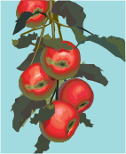  1 | 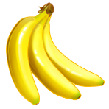  2 | 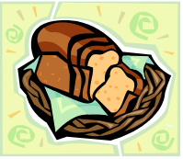  3 | 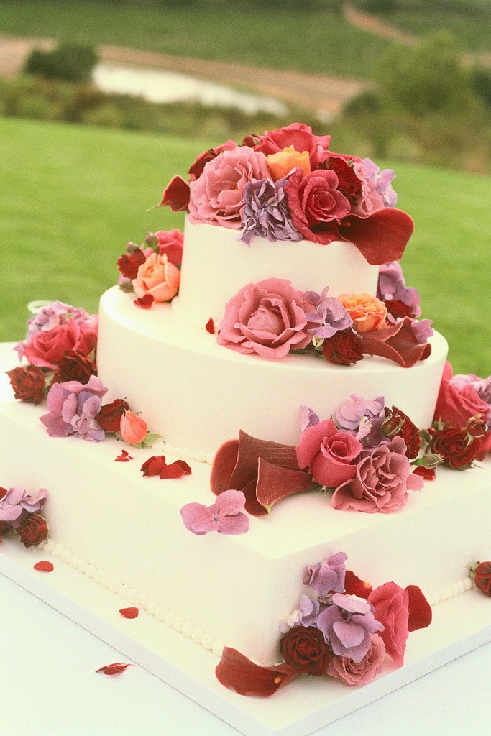  4 | 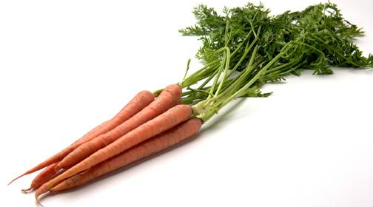  5 | 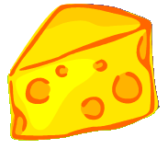  6
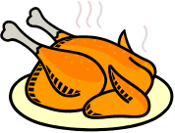  7 |   8 | 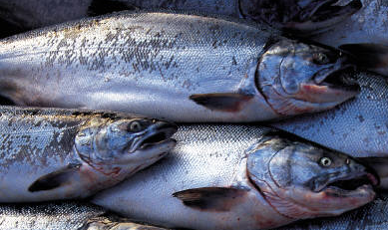  9 | 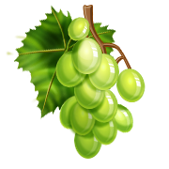  10 | 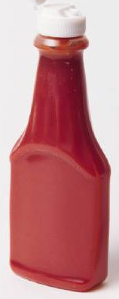  11 | 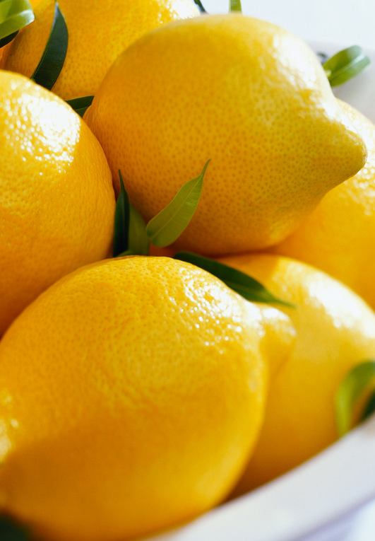  12
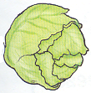  13 |   14 | 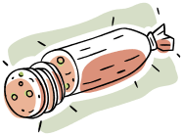  15 | 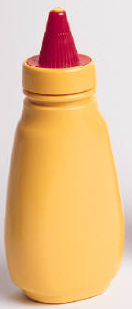  16 | 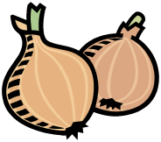  17 | 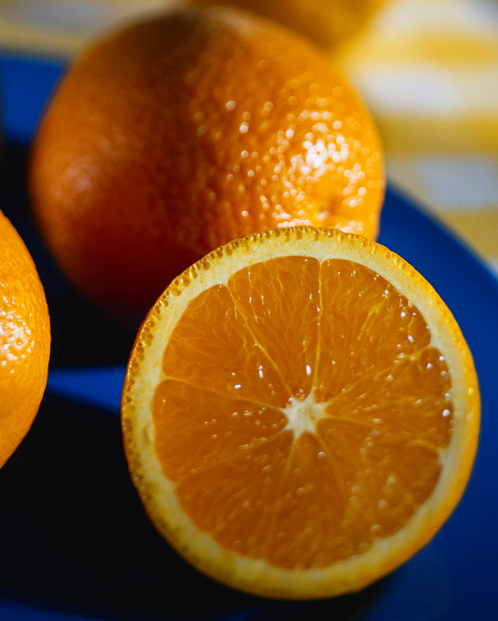  18
  19 | 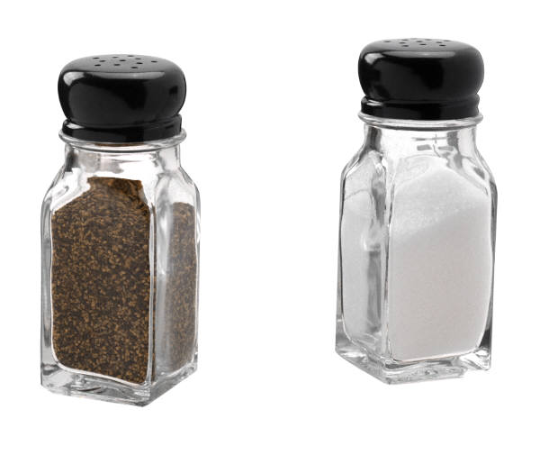  20 |   21 | 22 | 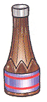  23 | 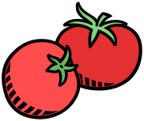  24

1. apples 7. chicken 13. lettuce 19. pears
2. bananas 8. egg 14. mayonnaise 20. pepper
3. bread 9. fish 15. meat 21. potatoes
4. cake 10. grapes 16. mustard 22. salt
5. carrots 11. ketchup 17. onions 23. soy sauce
6. cheese 12. lemons 18. oranges 24. tomatoes

1 Food Vocabulary Pictures
FOOD CATEGORIES CARDS:
FOOD  1. donut  2. rice  3. soup  4. cheese  5. fish | FOOD  1. yogurt  2. chicken  3. butter  4. cake  5. cookies | FOOD  1. beans  2. beef  3. ice cream  4. pasta  5. eggs | BEVERAGES  (DRINKS)  1. juice  2. milk  3. tea  4. pop  5. coffee
FRUIT  1. banana  2. pear  3. peach  4. pineapple  5. orange | FRUIT  1. apple  2. nectarine  3. grapes  4. mango  5. watermelon | VEGETABLES  1. carrot  2. potato  3. onion  4. lettuce  5. spinach | VEGETABLES  1. corn  2. cucumber  3. mushroom  4. peas  5. tomato

FOOD CATEGORIES CARDS:
FOOD  1. donut  2. rice  3. soup  4. cheese  5. fish | FOOD  1. yogurt  2. chicken  3. butter  4. cake  5. cookies | FOOD  1. beans  2. beef  3. ice cream  4. pasta  5. eggs | BEVERAGES  (DRINKS)  1. juice  2. milk  3. tea  4. pop  5. coffee
FRUIT  1. banana  2. pear  3. peach  4. pineapple  5. orange | FRUIT  1. apple  2. nectarine  3. grapes  4. mango  5. watermelon | VEGETABLES  1. carrot  2. potato  3. onion  4. lettuce  5. spinach | VEGETABLES  1. corn  2. cucumber  3. mushroom  4. peas  5. tomato

1 Food Categories Cards
2. Count / Non-Count Nouns

Activity 2

Purpose:
- to introduce count and non-count nouns
- to introduce quantities and containers

CLB Level:
3

Time:
45 minutes

Materials:
- Quantities Worksheet for each learner
- one set of Quantities Picture Cards for each pair of learners

Instructions:

1. Explain to the learners what countable nouns are e.g. oranges, cookies, carrots. Explain what non-countable nouns are e.g. milk, bread, ham
Countable nouns – I want 2 oranges.
Non- Count nouns – I want 2 cartons of milk.

2. Explain that to ask for the quantity of a countable noun, How many is used,
e.g. How many (oranges/cookies/carrots) do you want?
Explain that to ask for the quantity of a non-countable
noun how much is used, e.g. How much (milk/bread/ham)
do you want?

3. Introduce how containers are used to count non-countable food items e.g.:
a) a jar of jam / mayonnaise / etc…
b) a bottle of ketchup / oil / wine / etc…
c) a box of cereal / salt / etc…
d) a bag of flour / chips / etc…
e) a can of soup / beans / etc…
f) a package of cookies / etc…
g) a dozen eggs
h) a carton of milk (2litres) / cream / etc…
i) a bunch of bananas / grapes / etc…
j) a head of lettuce / cabbage / etc…
k) a jug of milk (4 litres) / juice / etc…
l) 200 grams of cheese / ham / etc…
m) a container of ice cream / margarine / etc…
4. Hand out the Quantities worksheet to each learner. Have them label each picture according to their containers and / or quantities. Have learners match the quantity and container with the appropriate kind of food for each at the bottom of the page.

5. Divide the learners into pairs and hand out a set of cards.
Have them place the cards face down on the table.

6. Write this dialogue on the board or on an OHT:
A: How much ______ do you want? or A: How many ______ do you want?
B: I want ____ _____ of ______. or B: I want ______ ______ of _____.
1 carton milk 1 bunch grapes
1 loaf bread 2 - apples

7. Have the learners turn over a card and they both look at it.
Learner A must make a correct question to learner B, depending on the picture:
e.g. if the card has a picture of 2 oranges on it,
learner A makes a question for learner B:
“How many oranges do you want?”
learner B answers: “I want 2 oranges.”

8. The learners should ask and answer according to what the picture is showing. Learners continue practicing the dialogue until all the cards are finished.

QUANTITIES WORKSHEET

Label the Pictures

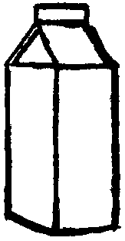 | 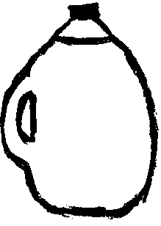 |  | 
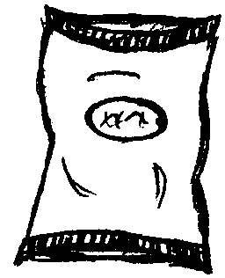 | 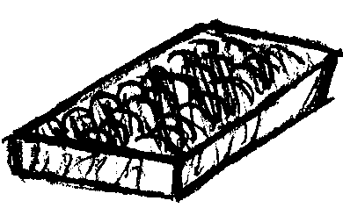 | 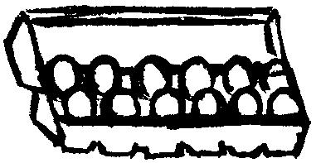 | 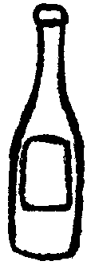
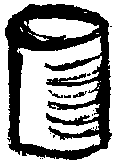 |  | 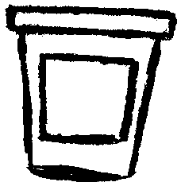 | 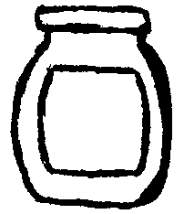

Match

- jar a) of cheese
- bottle b) eggs
- box c) of cereal
- bag d) of bananas
- can e) of milk (2 litres)
- package f) of jam
- dozen g) of milk (4 litres)
- carton h) of soup
- bunch i) of cookies
- head j) of ice cream
- jug l) of lettuce
- 200 grams m) of ketchup
- container n) of flour

2 Quantities worksheet

QUANTITIES PICTURE CARDS
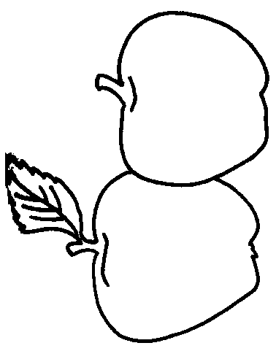 | 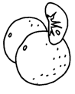 | 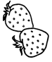 | 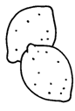
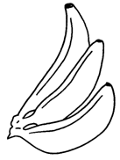 | 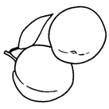 | 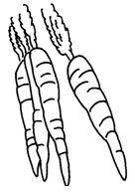 | 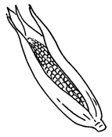
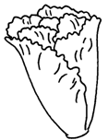 | 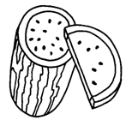 | 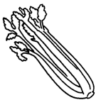 | 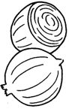
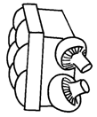 | 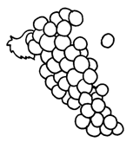 | 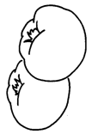 | 
2 Quantities picture cads 1

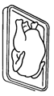 | 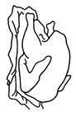 | 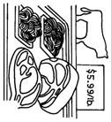 | 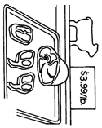
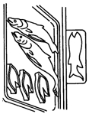 | 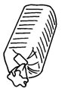 | 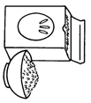 | 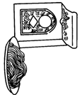
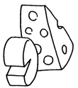 | 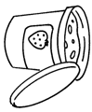 | 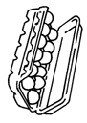 | 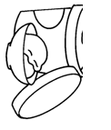
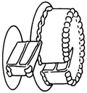 | 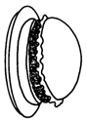 | 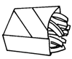 | 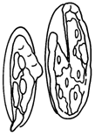

2 Quantities Picture Cards 2

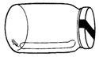 | 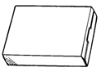 | 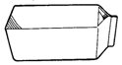 | 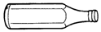
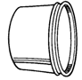 | 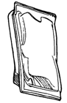 | 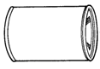 | 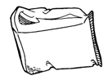
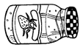 | 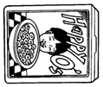 | 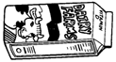 | 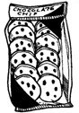
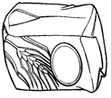 | 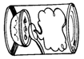 | 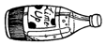 | 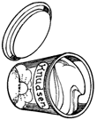

2 Quantities Picture Cards 3
3. John Goes Shopping

Activity 3

Purpose:
- to review food vocabulary
- to introduce shopping and quantity vocabulary
- to introduce and practice cashier/ customer dialogue

CLB Level:
3+

Time:
30 – 40 minutes

Materials:
- John Goes Shopping worksheet for each learner (double sided copy)
- Vocabulary OHT(Overhead Transparency)

Instructions:
1. Brainstorm with the learners words that could fit into each
of the sections on the Vocabulary OHT (overhead
transparency). Then, add any that they haven’t come up
with on their own and explain if necessary.

2. Hand out a copy of John Goes Shopping worksheet to
each learner. Read the text together, ensuring that the
words are understood and pronounced correctly.

3. Introduce some of the new vocabulary and ideas, such as quantities vocabulary, sections of a supermarket, and other shopping vocabulary.

- Give the learners time to answer the comprehension questions at the bottom of the page. Go through the answers together.
*This could be done as a pair activity with the learners asking each other the questions.

6. Lead a class discussion about common questions that
could be asked of them when they go grocery shopping.
Together with the learners, make a chart on the board of
possible questions or comments and appropriate responses
for each. The teacher may wish to reinforce this by
pairing the students and having them make a dialogue
modeling some of these possibilities.

Quantities: | Sections: | Other Vocabulary:
a few  head  bunch  bag  grams  loaves  carton  dozen  can  jar  box  package | Produce  Deli  Bakery  Dairy | groceries  shopping cart  loonie  check-out  cashier  receipt

3 Vocabulary OHT
JOHN GOES SHOPPING

John is hungry. He goes into the kitchen to cook some food, but there isn’t any food. So, John drives to Superstore to buy groceries. He needs a lot of groceries, so he decides to get a shopping cart. He finds a loonie and pushes the shopping cart into the store. He needs fruit and vegetables, so he goes to the produce section. Here, he gets a few tomatoes, a head of lettuce, a bunch of bananas, and a bag of potatoes. Next, he goes to the deli. He asks for 100 grams of cheese and 100 grams of pepperoni. Then, he goes to the bakery. At the bakery, he gets two loaves of bread. After that, he goes to the dairy section and gets a carton of milk and a dozen eggs. Next he finds a can of soup, a jar of jam, a box of tea, and a package of cookies.
John is finished, so he goes to the check-out to pay for his groceries.

“Hi. How are you today?” The cashier says.
“Good. And you?” John says.
The cashier says, “Good, but February is too cold for me.”
“Me too.” John answers.
The cashier rings up his purchases and asks, “Do you need any bags?”
“3, please.” John answers.
The cashier gives John his bags and his receipt.
“Have a nice day!” She says.
“Thanks. You, too.” John answers.

Then, he puts his groceries into the bags and goes home to make some supper.

QUESTIONS

1) Why does John go to Superstore? __________________________________________________

2) Why does John need a shopping cart? _______________________________________________

3) Where does John go first? ________________________________________________________

4) What does John get in the dairy section? ____________________________________________

5) How much cheese does John buy? _________________________________________________

6) How much soup does John buy? __________________________________________________

7) Who does John talk to at the check-out? _____________________________________________

8) What two things does the cashier give John? ____________________________________________

3 John Goes Shopping worksheet
4. What Is It?

Activity 4

Purpose:
- to review clothing vocabulary

CLB Level:
3

Time:
20 minutes

Materials:
- set of cards for each group of learners

Option:
- 20 card vocabulary set doubled (40 cards) for each group of learners
(Pictures taken from Oxford Classic Classroom Activities)

Instructions:

1. Have various clothing items on an OHT or draw them on the board. Ask the learners what each item is, writing the name beside each one. Use the pictures from the cards to ensure that the vocabulary is reviewed.

2. Divide the class into groups of 3. Hand out a set of cards to each group.

- Explain that the focus of this activity is to guess the English name for each picture.

4. Have the learners take turns turning over a card and holding it up for the other learners to see. The other members in the group see who can guess the correct name first. The first one to guess correctly gets to keep the card. The winner will be the one with the most cards at the end of the activity.

Option:
Choose about 20 cards of vocabulary which the learners need reinforced the most. Divide the class into groups of 3 or 4. Hand out a 20 card vocabulary set and have them lay all the cards face down on the table in front of them and take turns turning over the cards until they have a match. (based on the game Memory or Concentration)

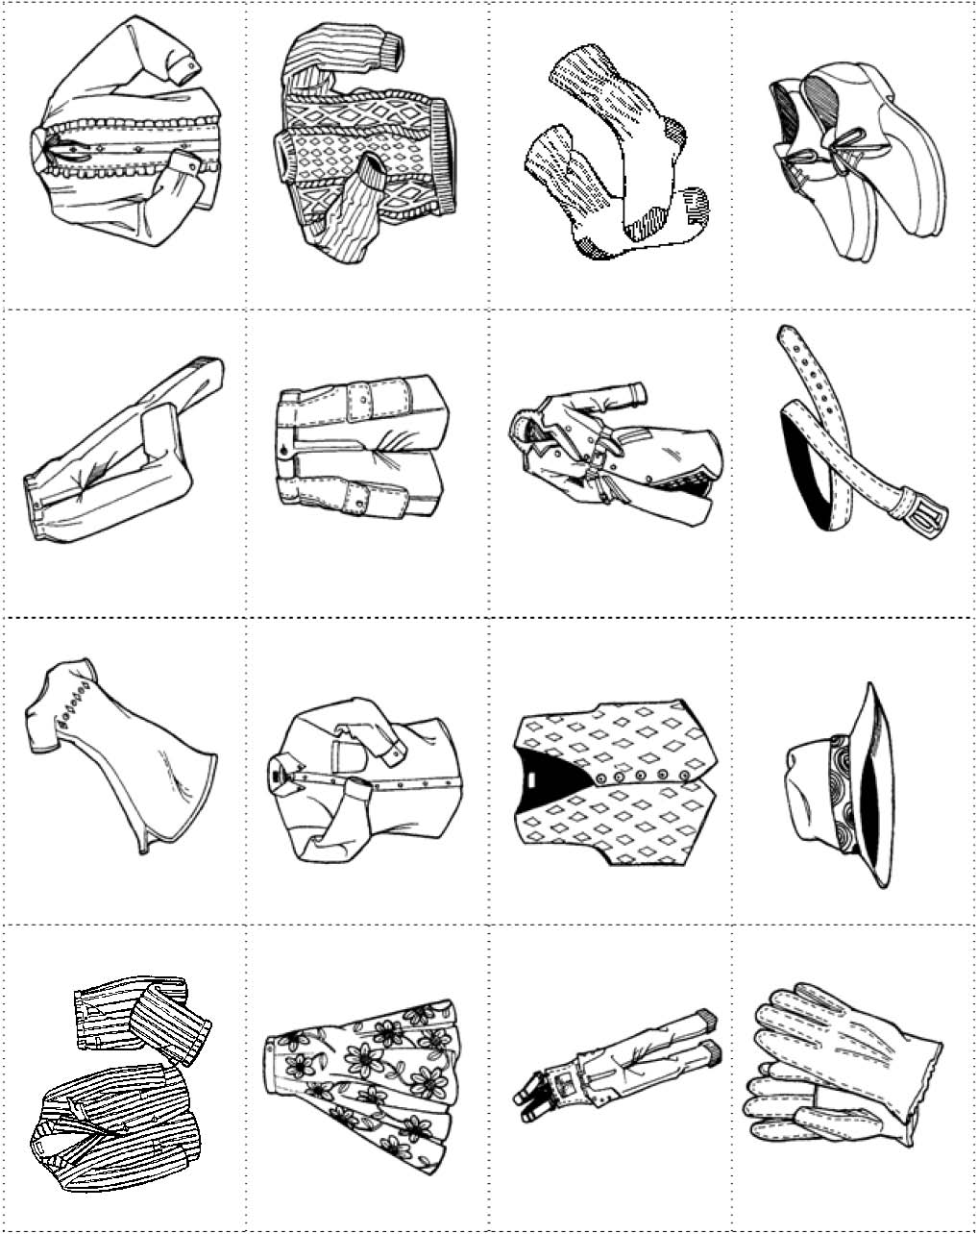
4 Clothing cards 1
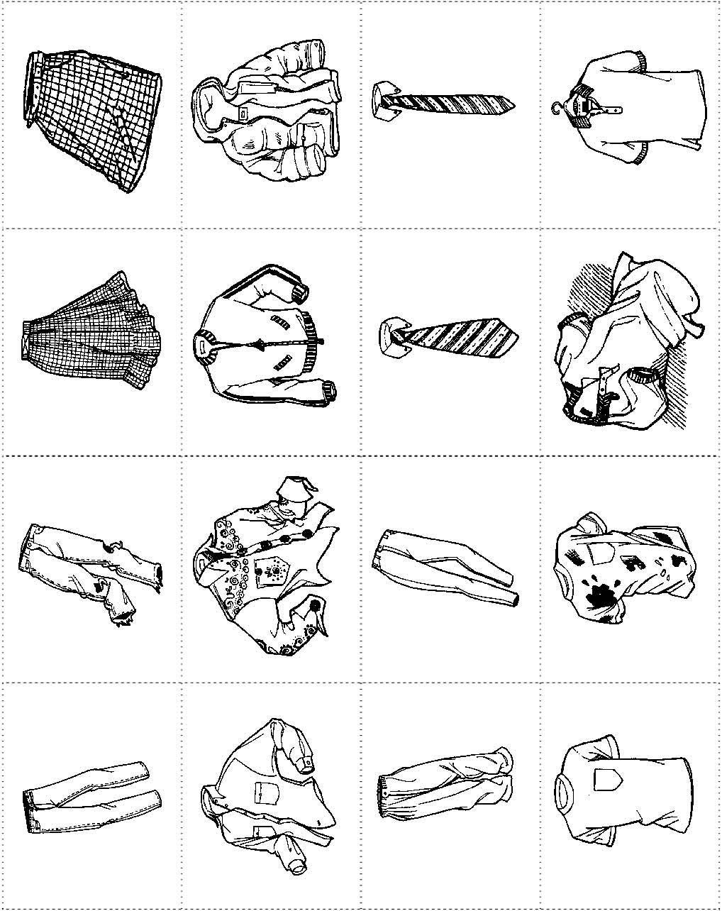
4 Clothing cards 2
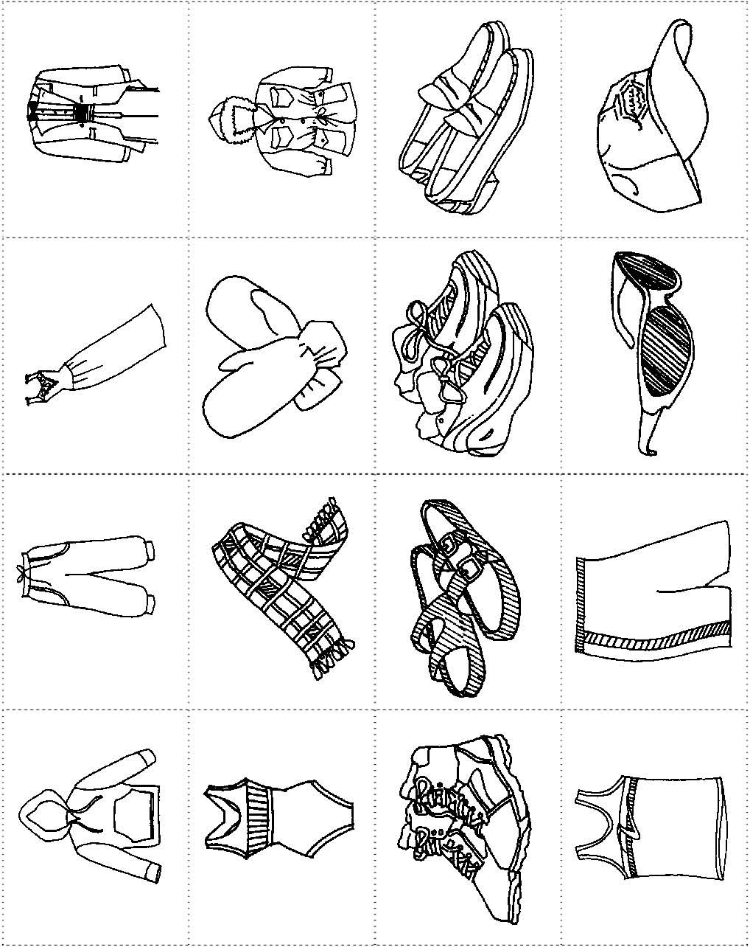

4 Clothing cards 3
5. It Doesn’t Fit!

Activity 5

Purpose:
- to practice using too and not enough
- to introduce a dialogue for returning and exchanging items in a store
- review clothing adjectives

CLB Level:
3 +

Time:
45 minutes

Materials:
- It Doesn’t Fit worksheet for each learner
- Returns and Exchanges worksheet for each learner (each page makes 2 copies)

Instructions:

1. On the board the teacher could draw or demonstrate various problems customers might have with clothing they’d either like to purchase or have already purchased. Explain the grammar for this on the board:
Too e.g. This shirt is too big.
Rule: Use too with is / am /are in a positive sentence.
Place too before the adjective.
Not Enough e.g. This shirt is not small enough.
Rule: Use not enough with is / am / are in a negative sentence.
Place not before the adjective and enough after the adjective.
Singular and Plural nouns for clothing
-remind students that we use it with shirts, skirts,
dresses, etc… and we use they with pants, shorts,
stockings, sunglasses, etc…

2. Hand out the It Doesn’t Fit worksheet to each learner. Have them make a correct sentence to explain each picture.

- Have students check their answers in pairs – one students using the too expression and the other student echoing them using the not __ enough expression for each question.

4. Brainstorm with students about returning and exchanging items at the store. Have students share their experiences with doing this in Canada. Review possible expressions which could be used for returning and exchanging.

5. Divide the learners into pairs. Hand out the Returns and Exchanges dialogue worksheet to each learner. Go through the dialogue with the learners to make sure vocabulary and content is understood.

6. Have the learners practice the dialogue together, suing the substitutions in the boxes.
It doesn’t fit!

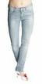

1) They don’t fit! They’re too _________________.
They’re not _________________ enough.

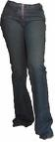

2) They don’t fit! They’re too _________________.
They’re not _________________ enough.

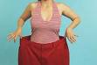
3) They don’t fit! They’re too _________________.
They’re not _________________ enough.

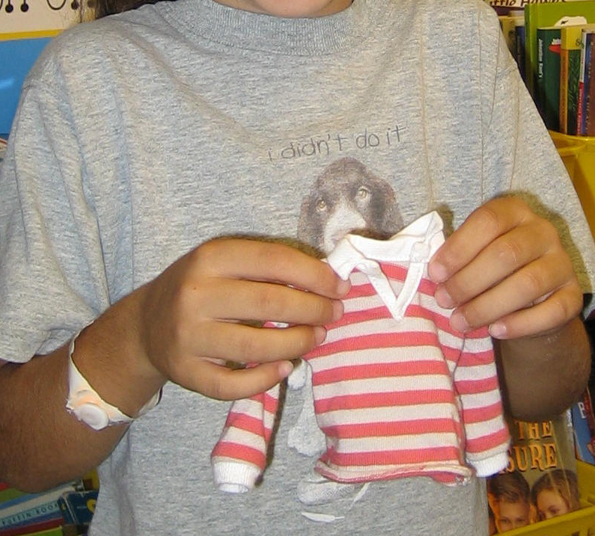
4) It doesn’t fit! It’s too _________________.
It’s not _________________ enough.

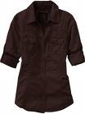
5) It’s not right! It’s too _________________.
It’s not _________________ enough.

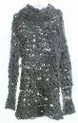
6) It’s not right! It’s too _________________.
It’s not _________________ enough.

5 It Doesn’t Fit worksheet
RETURNS and EXCHANGES

A: I want to return this __________.
B: What’s wrong with it?
A: It isn’t _________ enough. It’s too __________.
B: When did you purchase it?
A: I bought it last week.
B: OK…Do you have your receipt?
A: Yes, here it is.
B: OK. You can exchange it or get your money back.
A: I’d like to ___________________.
1) – jacket  - loose / tight  - exchange it, please | 2) – dress  - big / small  - return it, please | 3) – sweater  - casual / fancy  - exchange it, please | 4) – coat  - thick / thin  - return it, please | 5) – hat  - low / high  - exchange it, please

RETURNS and EXCHANGES

A: I want to return this __________.
B: What’s wrong with it?
A: It isn’t _________ enough. It’s too __________.
B: When did you purchase it?
A: I bought it last week.
B: OK…Do you have your receipt?
A: Yes, here it is.
B: OK. You can exchange it or get your money back.
A: I’d like to ___________________.
1) – jacket  - loose / tight  - exchange it, please | 2) – dress  - big / small  - return it, please | 3) – sweater  - casual / fancy  - exchange it, please | 4) – coat  - thick / thin  - return it, please | 5) – hat  - low / high  - exchange it, please

5 Returns and Exchanges worksheet
6. Shopping Survey

Activity 6

Purpose:
- to ask questions for a class survey
- to review adverbs of frequency
- to discuss the answers on a survey
- to form survey questions

CLB Level:
3/4

Time:
20 minutes

Materials:
- Shopping Survey worksheet for each learner (each page makes 2 copies)

Instructions:

1. With a CLB 3 class, you may wish to review the ideas and vocabulary before doing the activity, so that everyone can understand and respond appropriately. The teacher may also wish to review the adverbs of frequency on the board with learners. (ex. Always, Never, Seldom, etc…)

2. Hand out a Shopping Survey worksheet to all the learners. Have them walk around the class, asking the questions on their survey to other learners in the class. Ask them to continue talking about the question they’ve asked of that learner for 30 seconds to a minute, trying to create a short conversation based on each question. After they’ve asked the question, they can write the learner’s name beside the question under the name column. Then, they should move on to another learner and another question.

3. After this activity is finished, facilitate a short discussion with the learners on the topics presented in the survey.

4. With a CLB 4 class, review only a select amount of the ideas or vocabulary and then let them do the activity. The activity would be carried out in the same way as for a CLB 3 class (Instruction #2).

5. After, the teacher divides the class into small groups. The group chooses one question for which they are to come up with 2 new questions.
(ex. A: What clothes have you bought in Canada?
New question #1 – Where do you usually go shopping in Canada?
New question #2 – Do you like shopping for clothes better in Canada or in your last country?

6. Then, the groups could take turns asking their questions to the class in order to create a more learner-led class discussion.

SHOPPING SURVEY

QUESTIONS | NAME
How often do you go shopping for clothes?
What piece of clothing do you buy the most often?
What colors of clothing do you buy the most often?
What clothes have you bought in Canada?
Are Canadian sizes bigger or smaller than in your last country?
How much should a nice sweater cost?
Have you ever been to a garage sale?
What is something you’ve bought in Canada that you wish you hadn’t?

SHOPPING SURVEY

QUESTIONS | NAME
How often do you go shopping for clothes?
What piece of clothing do you buy the most often?
What colors of clothing do you buy the most often?
What clothes have you bought in Canada?
Are Canadian sizes bigger or smaller than in your last country?
How much should a nice sweater cost?
Have you ever been to a garage sale?
What is something you’ve bought in Canada that you wish you hadn’t?

6 Shopping Survey
7. The Height, Depth and Width

Activity 7

Purpose:
- to learn measurements vocabulary
- to ask questions specific to buying large household items

CLB Level:
3

Time:
20 minutes

Materials:
- Asking Questions About Furniture and Appliances worksheet for each learner
- pictures of large appliances cut out from a Sears catalogue (The corresponding information with the appliance must be included.)
- Shopping Questions for each group of 3 or 4

Instructions:

1. Ask learners if they have bought any large furniture items or appliances lately. Ask questions such as:
Where did you buy it? Do you have a warranty? Did you take it home or get it delivered?

2. Hand out Asking Questions About Furniture and
Appliances worksheet to learners and go through the first
section together taking note of the noun/adjective
relationship of measurements. Discuss the words
warranty and discount. Once learners understand
the vocabulary, have them listen to the conversation and
fill in the information. Repeat if necessary. Go through
the dialogue together to make sure everyone has the
correct information and any new vocabulary such as
dimensions, adjustable and return. Have learners go over
the dialogue with a partner.

3. Cut out pictures of different large appliances from a Sears
catalogue and glue them on paper so that you can add
extra information on some of them such as:

Warranty: 1 year for parts and service. Warranty: 1 year for parts only.
Delivery: 3 days -- cost: $20.00 & Can buy extra for service.
Discount: $50.00 -- energy efficient Delivery: 2 weeks
Cost: After 10 km. $20.00

Learners use the information from the advertisements to
fill in the information for #3 on the worksheet. They then
work together with a partner that does not have the same
appliance and share the information about their own.
They can then decide which refrigerator they would buy.

4. In groups of 3 or 4 have learners discuss the Shopping
Questions. Go through questions together for new
vocabulary and to make sure the questions are understood.

Dialogue to be read to learners:

A: Hi, I have some questions about your bookshelves.
B: Oh yes, what would you like to know?
A: Well, I'd like to check the dimensions first. How wide is it?
B: This one is 48" wide.
A: And the height?
B: It's 60” high and the shelves are adjustable.
A: How deep are they?
B: They're 12" deep.
A: How much are they?
B: $99.99 for one and 2 or more you get a 10% discount.
That would be $90.00 each.
A: Is there a warranty?
B: You have 30 days to return it if you don’t want it.
A: OK. What about delivery?
B: How far are you from the store?
A: About 8 km.
B: Then there is no charge for delivery.
A: When can you deliver it?
B: In 3 days. We’ll call you before we come.
A: OK. Thank you.
B: Thanks and come again.

Asking Questions about Furniture and Appliances

1. Complete the chart with the words on the right.
high
long
wide
much
far
deep
deliver
Noun Adjective

What is the width? How _______________ is it?
What is the length? How _______________ is it?
What is the depth? How _______________ is it?
What is the height? How _______________ is it?
distance -- How ____________ are you from here?
time -- When can you ______________ it?
price -- How _______________ is it?

1. Listen to the conversation and fill in the information.
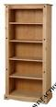
What is the width? ________________________
What is the height? ________________________
What is the depth? ________________________
What is the unit price? ______________________
What is the discount price for 2 or more? _________________________
What is the warranty? ___________________________
How far is the customer from the store? __________________________
When can the bookshelves be delivered? ____________________________

3. Look at a large appliance and use the dialogue to fill in the information.

A: Hi, I have some questions about your refrigerator.

B: Oh yes, what would you like to know?
A: Well, I'd like to check the dimensions first. How wide is it?
B: ________________________________________
A: And the height?
B: ________________________________________
A: How deep are they?
B: ________________________________________
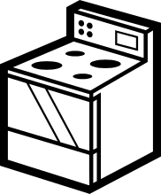
A: How much are they?
B: ________________________________________
A: Is there a discount?
B: ________________________________________
A: Is there a warranty?
B: ________________________________________
A: OK. What about delivery? How much is it?
B: ________________________________________
A: When can you deliver it?
B: ______________________ We’ll call you before we come.
A: Thanks. 7 Asking Questions About Furniture and Appliances
1. When you buy something, do you “shop around” and go to many
stores to compare prices?
2. When you buy something, what is most important to you: price,
quality or fashion trend?
3. What’s the most expensive thing you have ever bought?
4. Which appliance was the most expensive that you bought in Canada?



1. When you buy something, do you “shop around” and go to many
stores to compare prices?
2. When you buy something, what is most important to you: price,
quality or fashion trend?
3. What’s the most expensive thing you have ever bought?
4. Which appliance was the most expensive that you bought in Canada?



1. When you buy something, do you “shop around” and go to many
stores to compare prices?
2. When you buy something, what is most important to you: price,
quality or fashion trend?
3. What’s the most expensive thing you have ever bought?
4. Which appliance was the most expensive that you bought in Canada?



1. When you buy something, do you “shop around” and go to many
stores to compare prices?
2. When you buy something, what is most important to you: price,
quality or fashion trend?
3. What’s the most expensive thing you have ever bought?
4. Which appliance was the most expensive that you bought in Canada?

7 Shopping Questions

